

**PROXY AUTHORIZATION FORM**

The undersigned, …………………………, personal number ....................., in the capacity of representative of ……………………, seat and registered office ………………………, No ………………., street…… , fl.……., a company duly entered in the commercial register of the Registry Agency with company identification code …………….. - holding ....................... / ....................... / registered voting shares in uncertificated (dematerialized) form from the capital of Telelink Business Services Group AD, Sofia, pursuant to Art. 116, para. 1 of the Public Offering of Securities Act (POSA)

**HEREBY MAKE, CONSTITUTE AND APPOINT:**

**In the case of proxy – natural person**

**…………………………**, personal number ....................., residing at ………… No, ………………. Str., ……fl., ………. flat, ………..city

**In case of proxy – legal entity**

**……………………**, seat and registered office ………………………, No ………………., street…… , fl.……., company identification code: ………………………, duly represented by …………………………, personal number....................., identity card № ……………., issued by the Ministry of Interior ………… on ......................., in the capacity of .....................................

to represent me/the company, managed by me, at the Extraordinary General Meeting of the shareholders of Telelink Business Services Group AD, convened for 14 September 2021 at 10:00 a.m. EET = UTC + 3 (Coordinated Universal Time UTC) at the company's headquarters: 6 Panorama Sofia Street, Richhill Business Center, ground floor, Richhill Conference Center, Malinova Dolina, district of Vitosha, Sofia, respectively in the absence of a quorum for 30 September 2021 at 10.00 a.m. (Eastern European Standard Time EET = UTC + 3 (Coordinated Universal Time UTC)) at the same place and with the same agenda and to vote with all ........................... shares hold by me/the company, represented by me on the items of the agenda in the below referred manner and in particular:

**I. Procedural matters:**

**1. Election of a chairman, secretary and teller of votes for holding the General meeting.**

Proposed resolution: The General meeting of shareholders elects Mr. Ivan Zhitiyanov (and in his absence Ms. Nikoleta Stanailova) as Chairman, Mr. Ivan Daskalov (and Mrs. Daniela Peeva in his absence) as Secretary and teller of votes - Ms. Nikoleta Stanailova (and in her absence Mrs. Silviya Marinova)

**Vote:**

………………………………

(„In favour“, „Against”, „Abstention”)

**II. Matters of substance:**

**1. Adoption of the 6-month financial statement for the first half of 2021**

Proposed resolution: The General meeting of shareholders adopts the 6-month financial statement of the Company for the first half of 2021

**Vote:**

………………………………

(„In favour“, „Against”, „Abstention”)

**2. Taking a decision under art. 41 para. 2 of the Articles of Association of the Company for distribution of the profit and payment of a 6-month dividend**

Proposed resolution: The General Meeting of shareholders adopts a resolution for distribution of a 6-month dividend in the amount of BGN 10 250 000 (ten million two hundred and fifty thousand) or BGN 0.82 (eighty-two stotinki) per share of the profit realized by the Company, as BGN 677 786.42 are from the profit of the Company for 2020 and BGN 9 572 213.58 from the profit of the Company, realized according to the prepared 6-month financial report for the first half of 2021 and on the basis of the Report prepared by the Managing board on compliance with the requirements of art. 115c POSA. The right to receive a six-month dividend have the persons entered in the registers of the Central Depository as such with the right to dividend as of the 14th day after the date of the general meeting. The General meeting of shareholders authorizes the Managing board of the Company to take all necessary legal and factual actions regarding the payment of the six-month dividend to the shareholders, including selection of a commercial bank, initial and final term for payment of the six-month dividend

**Vote:**

………………………………

(„In favour“, „Against”, „Abstention”)

**3. Election of a registered auditor to perform an independent financial audit for 2021**

Proposed resolution: The General meeting of shareholders elects "ERNST AND YOUNG AUDIT" OOD as an auditor to perform an independent financial audit of the annual financial statement of the Company for 2021 and on the consolidated annual financial statement of the Company for 2021

**Vote:**

………………………………

(„In favour“, „Against”, „Abstention”)

**4. Authorization of the Managing board of the Company for concluding transactions from the scope of art. 114, para. 1, item 2 POSA**

Proposed resolution: The General meeting of shareholders authorizes the Managing board of the Company to enter into transactions within the scope of art. 114, para. 1, item 2 POSA under the conditions and within the terms according to the Motivated report of the Managing board under art. 114a, para. 1 POSA regarding the expediency and conditions of transactions within the scope of art. 114, para. 1 POSA, expressed in the conclusion of a cash loan agreement between the Company and Telelink Business Services EAD

**Vote:**

………………………………

(„In favour“, „Against”, „Abstention”)

**5. Amendments and supplements to the Remuneration Policy of the members of the Supervisory and Managing Boards of the Company**

Proposed resolution: The General Meeting of Shareholders adopts changes in the Remuneration Policy of the members of the Supervisory and Managing Boards of the Company, as in Art. 18 of the Remuneration Policy of the members of the Supervisory and Managing Boards of the Company, the following amendments and supplements are made:

1. Paragraph 2 is amended as follows:

"(2) A member of the Managing board shall be qualified as a special leaver if his/her contract is terminated due to:

a) retirement,

(b) general and permanent incapacity for work,

c) dissolution of the Company with or without legal succession,

d) change of control over the Company, or

(e) for any other reason at the discretion of the Supervisory Board."

2. Paragraph 3 is amended as follows:

"(3) For special leavers the receipt of unpaid or unprovided variable remuneration shall continue to be carried out on the envisaged date(s) of receipt, as the variable remuneration shall be paid in proportion to the part of the three-year tracking period elapsed as of the date of occurrence of the respective event under para 2."

3. Paragraph 4 is created:

"(4) If during the respective three-year tracking period a member of the Managing board dies, the variable remuneration shall be paid in proportion to the three-year tracking period to his/her heirs at law, if they have expressed such a wish; if the death occurs after the expiry of the three-year tracking period, but before the variable remuneration is transferred to the member, the heirs are entitled to receive it in full. The variable remuneration shall be paid at the end of the three-year tracking period."

4. Paragraph 5 is created:

"(5) In case there are objective obstacles to the provision of variable remuneration in the form of shares (including but not limited to dissolution of the Company with or without legal succession, free trading in the Company's shares on an organized securities market shall be permanently ceased, etc.), at any time until the date of transfer of ownership of the shares, respectively until the date of granting the rights, the members of the Managing board will be entitled to receive the monetary equivalent of the variable remuneration in the form of shares, determined on the basis of:

- maximum number of shares, adjusted in proportion to the part of the three-year tracking period elapsed as of the date of occurrence of the objective obstacle/ cessation of trading;

- values of the criteria set for the period from the beginning of the three-year tracking period to the end of the last financial year before the date on which the objective obstacle/ cessation of trading arose;

- the average closing price of the shares on a regulated securities market for the last 30 days preceding the date of occurrence of the objective obstacle/cessation of trading."

**Vote:**

………………………………

(„In favour“, „Against”, „Abstention”)

**6. Taking a decision to provide the members of the Managing board with remuneration based on shares of the Company for 2021**

Proposed resolution: The General meeting of shareholders takes a decision and approves the provision to the members of the Managing board with remuneration based on shares of the Company for 2021

**Vote:**

………………………………

(„In favour“, „Against”, „Abstention”)

**7. Approval of a scheme for remuneration based on shares of the Company to the members of the Managing board for 2021**

Proposed resolution: The General meeting of shareholders approves a Scheme for remuneration based on shares of the Company to the members of the Managing board for 2021, as follows:

1. Maximum number of the remuneration shares

Up to 15 000 or 0.12% of all shares in the Company’s capital (expressed in percentage of issued share capital as of the date of this approval), which shall be allocated in full or in part based on the satisfaction of the conditions defined in art. 3.1, 3.2 and 3.8 below

2. Rules of granting

• The shares are granted by resolution of the Supervisory board to all members of the Managing Board, within the maximum number of the remuneration shares.

• The shares granted as remuneration to the executive members of the Managing Board, as well as to the members of the Managing Board engaged in the management of a subsidiary, process or function in the economic group of Telelink Business Services Group AD (the Group) will represent approximately 50% of the overall compensation of the respective member of the Managing board, but not more than 60% of their overall target compensation from the Group as a whole for the respective year, as estimated at the time of share granting.

• The shares granted as remuneration to the members of the Managing board who are not engaged in the management of a subsidiary, process or function in the Group will represent approximately 15% of the overall compensation of the respective member of the Managing board, but not more than 20% % of their overall target compensation from the Group as a whole for the respective year, as estimated at the time of share granting.

• The shares shall be distributed among the five members of the Managing Board as follows:

* executive member of the Managing Board – 43.5%;
* each of the three members of the Managing Board engaged in the management of a subsidiary, process or function in the Group of Telelink Business Services Group AD – 17.4%;
* member of the Managing board not engaged in the management of a subsidiary, process or function in the Group – 4.3%.

3. Conditions to the transfer of shares

3.1. The Managing board members shall be entitled to one third (33.33%), or a maximum of 5 000 of the granted shares subject only to a condition of continuing employment over three consecutive years. Therefore, a member laving the Group before the end of the three-year share vesting period shall not be entitled to receive their respective shares, except in cases allowed by the Supervisory board based on a reasoned opinion, or as provided in the Remuneration Policy regarding members of the Supervisory and Managing Board of the Company. Regarding the executive member of the Managing Board, the Supervisory Board may, where applicable, allow an exception to the continuous employment condition, but only on a partial and pro-rata basis.

3.2. The member of the Managing Board shall be entitled to two thirds (66.67%), or up to 10 000 of the granted shares (hereafter referred to as the “Performance Shares”, or “PS”) subject to long-term performance criteria linked to the Group’s targeted results.

3.3. The performance conditions are determined by the Supervisory Board. They are equal to all beneficiaries and apply to all granted PS.

3.4. Performance conditions are objective and measurable and include indicators relevant to the Group’s long-term course of business and consistent with the current environment in which it operates. They include criteria representative of the Company’s business and adapted to the specific nature of its activities.

3.5 All performance conditions are tracked over a reference period of three years, i.e. 2021, 2022 and 2023.

3.6 The 2021 PS are subject to performance conditions based on four complementary criteria for the results of Group operations, each whereof shall participate in determining the final number of transferred shares as follows:

• average Revenue growth shall contribute up to 20% of the maximum number of PS, or up to 13.33% of the total maximum number of granted shares;

• average Sales Profit growth shall contribute up to 30% of the maximum number of PS, or up to 20% of the total maximum number of granted shares;

• average EBITDA growth shall contribute up to 30% of the maximum number of PS, or up to 20% of the total maximum number of granted shares;

• average NPS shall contribute up to 20% of the maximum number of PS, or up to 13.33% of the total maximum number of granted shares;

where:

* “Revenue” shall mean consolidated net sales revenue;
* “Sales Profit” shall mean consolidated gross profit less sales and marketing expenses;
* “EBITDA” shall mean consolidated earnings before interest, tax depreciation and amortization;
* “NPS” (Net Promoter Score) is a metric of customer satisfaction, calculated as the difference between the percentage of clients with high and low likelihood of recommending the Group as a supplier in the total number of respondents among surveyed Group clients;
* “average growth” shall mean the compound annual growth rate (CAGR) for the period 2021-2023, calculated as the ratio of the value of each relevant indicator for 2023 to the value of the same indicator in 2020, raised to a power of 1/3, minus 1;
* “consolidated” shall mean the value reported or calculated on the basis of the annual consolidated financial statements of Telelink Business Services Group AD under IFRS.

3.7. The assessment of the achievement of the performance conditions shall be made as follows:

• the performance of each of the above criteria and the respective final number of transferred shares shall be established against predefined performance ranges specific to each criteria, as shown in the table as per section 3.8 below;

• the Supervisory Board must establish whether and to what extent the performance conditions were met by a duly justified resolution included in the Supervisory Board’s report to the General Meeting of Shareholders regarding the implementation of the Remuneration Policy;

• the assessment of the achievement of the performance conditions shall be made in 2024, after the confirmation of the audited consolidated financial statements of Telelink Business Services Group AD for 2023.

3.8. The number and percentage distribution of granted shares and the ranges of the final number of transferred shares according to the criteria as per sections 3.1 and 3.2 above, including the specific performance ranges and respective percentage and number of finally transferred shares, are summarized in the table below, as follows:

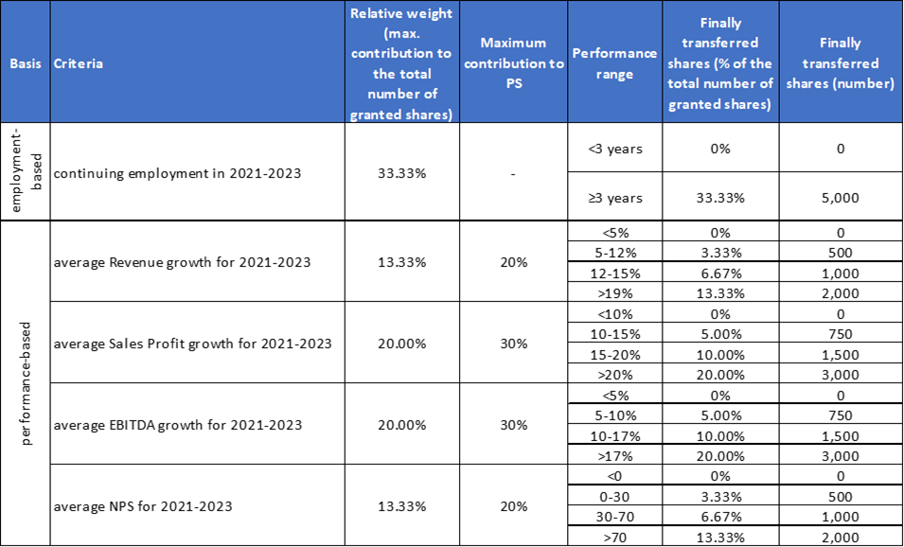

4. Transfer of share ownership

The transfer of ownership over the finally transferred shares shall follow the completion of the relevant three-year period for which the conditions are tracked, but not earlier than three years after the date of the Supervisory Board’s resolution on their granting.

5. Post-transfer share retention conditions

No conditions shall be defined or applied towards the retention of the shares after their transfer.

6. Deadline for the provision of remuneration in the form of shares

The Supervisory Board may grant to the members of the Managing Board share-based remuneration for 2021 by the end of December 2021, subject to the prior approval of this Schedule by the General meeting of shareholders.

**Vote:**

………………………………

(„In favour“, „Against”, „Abstention”)

The proxy is obliged to vote in the above-mentioned manner.

In the case of instructions for voting "Against" and "Abstention", the proxy has/ does not have the right to make additional motions on the agenda items at his/her discretion. The authorization covers/ does not cover issues that are included in the agenda according to the provisions of Art. 231, para. 1 of the Commerce Act and have not been announced pursuant to Art. 223 and Art. 223a of the Commerce Act. In the cases under Art. 231, para 1 of the Commerce Act, the proxy has / does not have the right whether to vote and in what way at his/her own discretion. In the cases under Art. 223a of the Commerce Act the proxy has/ does not have the right whether to vote and in what way, as well as to make/ not to make proposals for decisions on the additionally included issues in the agenda at his/her own discretion.

According to Art. 116, para. 4 of the Public Offering of Securities Act, delegation of the above referred rights shall be null and void.

**SIGNATURE: ______________________________**

*Notes:*

*1. For each of the items on the agenda, only one of the following votes must be indicated: ”In favour”, “Against” or “Abstention”.*

*2. The shareholder, giving the authorization, shall explicitly indicate one of the alternative options given in the final paragraph of the Proxy authorization form.*

*3. A member of the Company’s managing board may represent a shareholder at the general meeting of shareholders only if the shareholder has explicitly indicated in the proxy authorization form the manner of voting on each of the issues on the agenda.*